TurboQuant
On March 24, 2026, Google Research introduced TurboQuant – a compression method for KV-cache and vector search. Official documentation describes TurboQuant as a two-stage method: PolarQuant performs the main compression stage, and a 1-bit residual method called QJL eliminates bias in dot product estimation.
According to Google representatives, the method preserves accuracy when solving large-context tasks, while reducing KV memory consumption by at least 6× and increasing attention-logit computation speed on H100 GPUs by up to 8×.
Here are the key details of this development.

Main Goal
TurboQuant targets one of the key limitations of modern AI systems – high memory load during inference (the actual use of a model to generate answers). Unlike the training phase, which also demands huge resources, inference occurs with every user request; optimising it can make services significantly cheaper and more accessible.

What is TurboQuant?
TurboQuant is a KV-cache compression method, not a model weight quantisation technique. This distinction matters. The weights of a 70-billion-parameter model still require 140 GB of VRAM when using FP16, regardless of TurboQuant. Only the memory occupied by the key-value attention cache – generated during inference – changes.

Key Takeaways from the Paper
- 6× memory reduction in the KV-cache compared to BF16 storage.
- 8× speedup in attention computation compared to 32-bit (FP32) non-quantised keys (excluding overall inference throughput).
- Minimal accuracy loss on long-context benchmarks (LongBench, Needle In A Haystack, RULER, L-Eval).
- Data independence – no calibration dataset required.

Crucial Difference from Weight Quantisation (e.g., AWQ, GPTQ)
TurboQuant and weight quantisation work on different memory pools. They complement each other rather than being alternatives. You can apply AWQ to compress model weights, then run TurboQuant to compress the KV-cache during inference.

Claimed Results from Google Research
According to Google Research, the new technology achieves impressive figures:
- Memory consumption reduction – at least 6×.
- Speed increase – in certain scenarios inference speed can grow up to 8×.
The study conducted a comprehensive evaluation of three algorithms on standardised benchmarks focused on long-context tasks.
Benchmarks used: LongBench, Needle In A Haystack, ZeroSCROLLS, RULER, and L-Eval. Tested platforms were open large language models from the Gemma and Mistral families.
Experimental data indicate that TurboQuant demonstrates the best results across key metrics – dot-product distortion and recall – while simultaneously minimising the memory footprint of the key-value cache. The diagram below aggregates performance across various task categories (question answering, code generation, text summarisation) in comparison with baseline methods PolarQuant and KIVI.
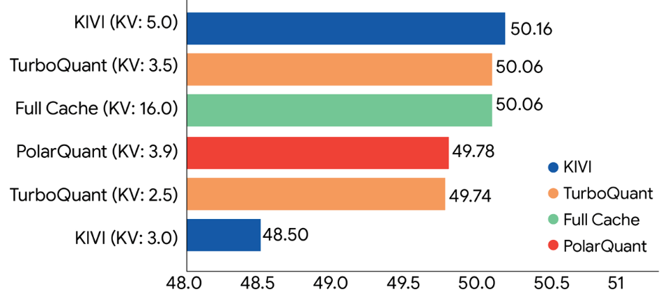
*(Quantization-2)*
TurboQuant shows high KV-cache compression performance on the LongBench test compared to various compression methods on the Llama-3.1-8B-Instruct model (bit width shown in parentheses). The method consistently outperforms alternative compression approaches across the full range of LongBench tasks.
Results for tasks requiring pinpoint information retrieval in large text corpora (“Needle In A Haystack” class) are shown below. In this scenario, TurboQuant again achieves accuracy identical to the uncompressed model at all test stages, while reducing KV-cache size by at least 6×. Similarly, PolarQuant shows nearly zero accuracy loss in this task.
It has been empirically proven that TurboQuant can quantise the KV-cache down to 3 bits without any retraining, fine-tuning, or measurable output accuracy degradation. Moreover, the algorithm’s implementation reduces operation time compared to the original unmodified Gemma and Mistral models. The approach is computationally efficient and introduces negligible runtime overhead.
The following graph illustrates the achieved speedup in attention-logit computation: in particular, the 4-bit TurboQuant configuration provides up to 8× performance gain relative to 32-bit non-quantised keys when running on NVIDIA H100 GPUs.
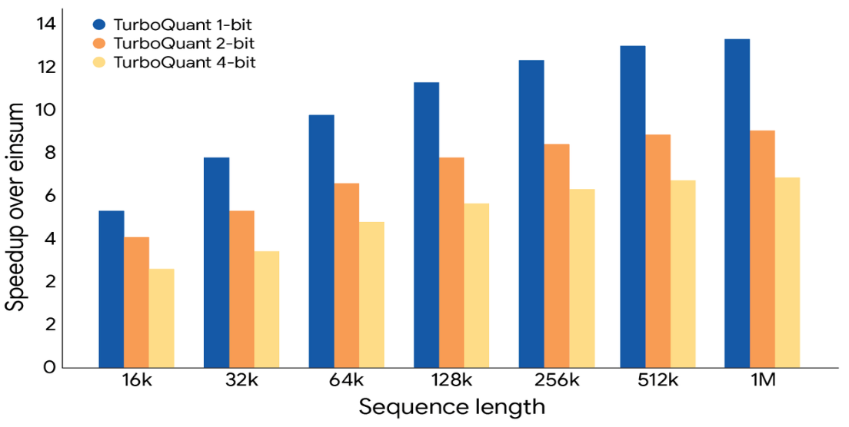
*(Quantization-3)*
TurboQuant demonstrates significant performance improvements in attention-logit computation on the KV-cache at various bit widths compared to a highly optimised JAX baseline.
These characteristics make the method ideal for vector-search application scenarios, where index building is substantially accelerated.
Google Research evaluated TurboQuant’s effectiveness on high-dimensional vector search against modern approaches (Product Quantization (PQ) and RabbitQ). The metric used was Recall@k – the frequency of correctly identifying the true nearest neighbour among approximately computed k candidates. Although baseline methods use large codebooks and require dataset-specific tuning, TurboQuant consistently shows higher recall (see figure below). This confirms the reliability and applicability of the proposed approach for high-dimensional search.
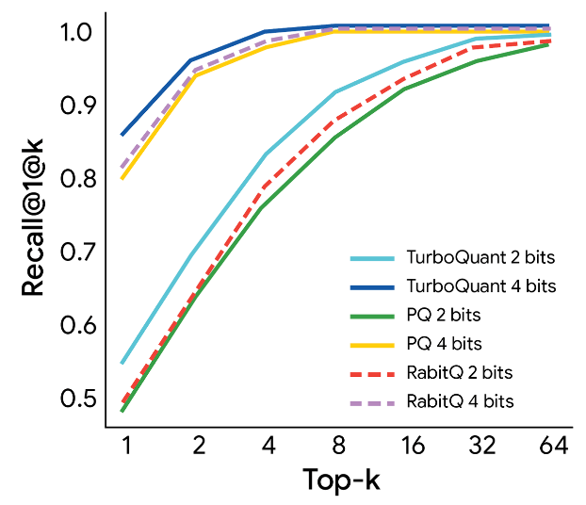
*(Quantization-4)*
Comparison on the GloVe dataset (d=200) shows that TurboQuant achieves optimal Recall@k values, surpassing modern vector quantisation methods in robustness.
The study concludes that TurboQuant marks a qualitative shift in high-dimensional search methodology. By setting a new performance bar, the method provides near-optimal speed-distortion trade-offs with minimal overhead. This opens the door to operating nearest-neighbour search subsystems in 3-bit mode without sacrificing the accuracy typical of much more resource-intensive models. Detailed theoretical foundations and algorithmic implementation are provided in the main text of the publication.
This Google Research study was conducted in collaboration with Pranit Kacham (Research Scientist, Google), Majid Hadian (Staff Engineer, Google DeepMind), Insu Han (Associate Professor, KAIST), Majid Daliri (PhD student, New York University), Lars Gottesbüren (Research Scientist, Google), and Rajesh Jayaram (Research Scientist, Google).

Independent Benchmark Results for TurboQuant
(Based on the Google Research blog post and arXiv paper 2504.19874 – treat these as claims from the paper.)
- LongBench aggregate result
TurboQuant at 3.5 bits scored 50.06 on Llama-3.1-8B – identical to the full FP16 cache (50.06). At 2.5 bits: 49.44. KIVI at 3 bits: 48.50.
- Needle-in-a-Haystack (4× compression)
TurboQuant: 0.997 – matching FP16 (0.997). For comparison: KIVI 0.981, PolarQuant 0.995, SnapKV 0.858.
- ZeroSCROLLS / RULER / L-Eval
The paper reports quality-neutral results at 3.5 bits for all three long-context tests. At 2.5 bits degradation is noticeable but minor.
- Vector search (GloVe, d=200)
TurboQuant outperforms Product Quantization and RaBitQ in recall@k. Indexing time: TurboQuant 0.002 seconds, Product Quantization 37–494 seconds, RaBitQ 597–3957 seconds – i.e., virtually lossless.
Reference KV-Cache Memory Footprint
(Batch size = 1, baseline FP16 vs. TurboQuant target 3 bits. Use a calculator for custom configurations.)
Model | 32k ctx FP16 | 32k ctx 3-bit TQ | 128k ctx FP16 | 128k ctx 3-bit TQ
Llama 3.1 8B | 4.0 GB | 0.75 GB | 16 GB | 3.0 GB
Llama 3.1 70B | 10 GB | 1.9 GB | 40 GB | 7.5 GB
Qwen 2.5 72B | 10 GB | 1.9 GB | 40 GB | 7.5 GB
Mixtral 8×7B | 4.0 GB | 0.75 GB | 16 GB | 3.0 GB

Industry Significance
The announcement of TurboQuant has already caused a notable market reaction because it challenges the earlier thesis that demand for expensive server memory (DRAM and HBM) would automatically and infinitely grow with AI development. If the technology proves effective in commercial products, it could lead to:
- Lower operating costs for AI services for businesses and end users.
- Greater accessibility of complex models that can run on less powerful (and cheaper) devices.

Important Caveats and Current Status
- Laboratory stage: The technology is still a research project and has not been deployed in public Google services. Its official presentation is expected at ICLR 2026.
- Not for training: TurboQuant solves memory consumption during inference, not the enormous cost of initial training.
- Market effect: Despite potential disruptiveness, experts believe that cheaper inference may actually spur even more frequent and widespread AI use, ultimately not leading to a drop in overall memory demand.

Cost Impact: Parallel Processing Changes Everything
TurboQuant does not reduce the number of GPUs required to load a model. But it radically changes how many users can be served per GPU-hour.
Setup: FP16 70B model on 2 on-demand H100 SXM5 GPUs at 2.90/hourperGPU(total2.90/hourperGPU(total5.80/hour). Available VRAM for KV-cache: 20 GB.
Context per user | Without TurboQuant | With TurboQuant | Parallelism gain
32k tokens | ~2 concurrent users | ~11 concurrent users | 5.5×
128k tokens | 0 users (does not fit) | 2–3 concurrent users | Now feasible
Cost per user-hour (32k context)
- Without TurboQuant: ~$2.90/hour
- With TurboQuant: ~$0.53/hour
→ 5.5× cheaper
Monthly run on this configuration (24/7): 5.80/hour×720hours=5.80/hour×720hours=4,176/month.
- Without TurboQuant: serves 2 users → $2,088 per user/month.
- With TurboQuant: serves 11 users → $380 per user/month.
For 128k context the situation is even more striking: workloads that previously required additional GPUs to free space for the KV-cache now run on the base configuration.

Implementation Status
As of April 2026, Google Research has not released an official Python implementation of TurboQuant. The method is described in detail in arXiv paper 2504.19874 (ICLR 2026). There is no public GitHub repository with an installable library. Follow Google Research on GitHub and the arXiv paper page for updates.
In the meantime, if you need to compress the KV-cache today, vLLM supports built-in FP8 KV-cache quantisation with the flag --kv-cache-dtype fp8. Compression is roughly 2× better than BF16 – not 6× like TurboQuant – but it is ready to use.

TurboQuant in Lean Manufacturing
TurboQuant does not directly affect manufacturing or “lean production” (lean technologies) yet, because it is a laboratory technology solving a narrow AI inference problem. However, its economic logic could have long-term consequences for industry that uses AI.
Here is how it might work in practice from a business and economics perspective.

1. Effect on Lean Manufacturing: Lowering AI Costs
The essence of lean manufacturing is waste elimination and resource optimisation. TurboQuant applies the same principle at the computer hardware level:
- Lower operational costs: The algorithm compresses AI’s “working memory” (KV-cache) by 6× and speeds up computation by up to 8×. In practice, this means the same server can serve more requests while consuming less electricity. For a factory that has deployed AI quality control or predictive analytics, this directly reduces cloud computing bills or depreciation of own servers.
- Jevons paradox: Analysts from Morgan Stanley and other investment houses point out that a sharp drop in technology cost usually expands, not reduces, its use. In lean manufacturing, this means it becomes economically justified to deploy AI analytics not only on final assembly but also on every intermediate machine or in the logistics chain, increasing overall system efficiency.

2. Impact on the Memory Supply Chain (DRAM/NAND)
The news about TurboQuant caused a temporary drop in memory manufacturer stocks because the market feared falling demand. However, for real manufacturing this means a redistribution of resources rather than a reduction:
- Reduced shortage: If AI models require less RAM to run, this could somewhat ease the global server memory shortage. For ordinary industrial enterprises, this potentially means smaller future price increases for server equipment.
- Increased model complexity: AI developers are likely to spend the freed-up memory not on savings but on making models “smarter” (e.g., increasing the context window to millions of tokens to analyse an entire factory’s documentation). Demand for advanced HBM memory chips – which TurboQuant does not directly compress – will remain high.

3. Practical Significance for Manufacturing
At present, direct application is limited to the development stage:
- Laboratory stage: The technology is not yet deployed in Google’s commercial products and is presented as a research paper.
- Niche application: The algorithm is currently most effective for very long requests (e.g., analysing thousands of pages of technical documentation). For fast tasks on a production line (instant defect detection), the gain may be less noticeable due to the overhead of compression itself.
Thus, for lean manufacturing, TurboQuant is for now a signal of a trend: the total cost of ownership of industrial AI will decrease, making “smart factory” technologies more accessible to small and medium businesses.

